**PROJECT DELIVARABLE 3**

**/* METADATA TABLE CREATION AND INSERTION */**

DROP TABLE METADATA_TBL CASCADE CONSTRAINTS;

CREATE TABLE METADATA_TBL(CNL_TABLE_NAME VARCHAR(255), CNL_COLUMN_NAME VARCHAR(255),CNL_DATA_TYPE VARCHAR(255),DB1_TABLE_NAME VARCHAR(255),DB1_COLUMN_NAME VARCHAR(255),DB1_DATA_TYPE VARCHAR(255),DB1_FUNCTION VARCHAR2(4000),DB2_TABLE_NAME VARCHAR(255),DB2_COLUMN_NAME VARCHAR(255),DB2_DATA_TYPE VARCHAR(255),DB2_FUNCTION VARCHAR2(4000), DB3_TABLE_NAME VARCHAR(255),DB3_COLUMN_NAME VARCHAR(255),DB3_DATA_TYPE VARCHAR(255),DB3_FUNCTION VARCHAR2(4000));

INSERT INTO METADATA_TBL (CNL_TABLE_NAME, CNL_COLUMN_NAME, CNL_DATA_TYPE, DB1_TABLE_NAME, DB1_COLUMN_NAME, DB1_DATA_TYPE, DB1_FUNCTION, DB2_TABLE_NAME, DB2_COLUMN_NAME, DB2_DATA_TYPE, DB2_FUNCTION, DB3_TABLE_NAME, DB3_COLUMN_NAME, DB3_DATA_TYPE, DB3_FUNCTION) VALUES ('BOOKS', 'BK_ID', 'NUMBER', 'BOOKS_TBL', 'ID', 'NUMBER', null, null, null, null, null, null, null, null, null);

INSERT INTO METADATA_TBL (CNL_TABLE_NAME, CNL_COLUMN_NAME, CNL_DATA_TYPE, DB1_TABLE_NAME, DB1_COLUMN_NAME, DB1_DATA_TYPE, DB1_FUNCTION, DB2_TABLE_NAME, DB2_COLUMN_NAME, DB2_DATA_TYPE, DB2_FUNCTION, DB3_TABLE_NAME, DB3_COLUMN_NAME, DB3_DATA_TYPE, DB3_FUNCTION) VALUES ('BOOKS', 'ISBN', 'NUMBER', 'BOOKS_TBL', 'ISBN', 'NUMBER', null, null, null, null, null, null, null, null, null);

INSERT INTO METADATA_TBL (CNL_TABLE_NAME, CNL_COLUMN_NAME, CNL_DATA_TYPE, DB1_TABLE_NAME, DB1_COLUMN_NAME, DB1_DATA_TYPE, DB1_FUNCTION, DB2_TABLE_NAME, DB2_COLUMN_NAME, DB2_DATA_TYPE, DB2_FUNCTION, DB3_TABLE_NAME, DB3_COLUMN_NAME, DB3_DATA_TYPE, DB3_FUNCTION) VALUES ('BOOKS', 'BK_PRODUCT_ID', 'NUMBER', 'BOOKS_TBL', 'PRODUCT_ID', 'NUMBER', null, null, null, null, null, null, null, null, null);

INSERT INTO METADATA_TBL (CNL_TABLE_NAME, CNL_COLUMN_NAME, CNL_DATA_TYPE, DB1_TABLE_NAME, DB1_COLUMN_NAME, DB1_DATA_TYPE, DB1_FUNCTION, DB2_TABLE_NAME, DB2_COLUMN_NAME, DB2_DATA_TYPE, DB2_FUNCTION, DB3_TABLE_NAME, DB3_COLUMN_NAME, DB3_DATA_TYPE, DB3_FUNCTION) VALUES ('BOOKS', 'BK_TITLE', 'VARCHAR2', 'BOOKS_TBL', 'TITLE', 'VARCHAR2', null, null, null, null, null, null, null, null, null);

INSERT INTO METADATA_TBL (CNL_TABLE_NAME, CNL_COLUMN_NAME, CNL_DATA_TYPE, DB1_TABLE_NAME, DB1_COLUMN_NAME, DB1_DATA_TYPE, DB1_FUNCTION, DB2_TABLE_NAME, DB2_COLUMN_NAME, DB2_DATA_TYPE, DB2_FUNCTION, DB3_TABLE_NAME, DB3_COLUMN_NAME, DB3_DATA_TYPE, DB3_FUNCTION) VALUES ('BOOKS', 'AUTHORS', 'VARCHAR2', 'BOOKS_TBL', 'AUTHORS', 'VARCHAR2', null, null, null, null, null, null, null, null, null);

INSERT INTO METADATA_TBL (CNL_TABLE_NAME, CNL_COLUMN_NAME, CNL_DATA_TYPE, DB1_TABLE_NAME, DB1_COLUMN_NAME, DB1_DATA_TYPE, DB1_FUNCTION, DB2_TABLE_NAME, DB2_COLUMN_NAME, DB2_DATA_TYPE, DB2_FUNCTION, DB3_TABLE_NAME, DB3_COLUMN_NAME, DB3_DATA_TYPE, DB3_FUNCTION) VALUES ('BOOKS', 'BK_PRICE', 'NUMBER', 'BOOKS_TBL', 'PRICE', 'NUMBER', null, null, null, null, null, null, null, null, null);

INSERT INTO METADATA_TBL (CNL_TABLE_NAME, CNL_COLUMN_NAME, CNL_DATA_TYPE, DB1_TABLE_NAME, DB1_COLUMN_NAME, DB1_DATA_TYPE, DB1_FUNCTION, DB2_TABLE_NAME, DB2_COLUMN_NAME, DB2_DATA_TYPE, DB2_FUNCTION, DB3_TABLE_NAME, DB3_COLUMN_NAME, DB3_DATA_TYPE, DB3_FUNCTION) VALUES ('BOOKS', 'BK_CATEGORY_ID', 'NUMBER', 'BOOKS_TBL', 'CATEGORY_ID', 'NUMBER', null, null, null, null, null, null, null, null, null);

INSERT INTO METADATA_TBL (CNL_TABLE_NAME, CNL_COLUMN_NAME, CNL_DATA_TYPE, DB1_TABLE_NAME, DB1_COLUMN_NAME, DB1_DATA_TYPE, DB1_FUNCTION, DB2_TABLE_NAME, DB2_COLUMN_NAME, DB2_DATA_TYPE, DB2_FUNCTION, DB3_TABLE_NAME, DB3_COLUMN_NAME, DB3_DATA_TYPE, DB3_FUNCTION) VALUES ('BOOKS', 'BK_DESCRIPTION', 'VARCHAR2', 'BOOKS_TBL', 'DESCRIPTION', 'VARCHAR2', null, null, null, null, null, null, null, null, null);

INSERT INTO METADATA_TBL (CNL_TABLE_NAME, CNL_COLUMN_NAME, CNL_DATA_TYPE, DB1_TABLE_NAME, DB1_COLUMN_NAME, DB1_DATA_TYPE, DB1_FUNCTION, DB2_TABLE_NAME, DB2_COLUMN_NAME, DB2_DATA_TYPE, DB2_FUNCTION, DB3_TABLE_NAME, DB3_COLUMN_NAME, DB3_DATA_TYPE, DB3_FUNCTION) VALUES ('CATEGORY', 'CTG_CATEGORY_ID', 'NUMBER', 'CATEGORY_TAB', 'CATEGORY_ID', 'NUMBER', null, null, null, null, null, null, null, null, null);

INSERT INTO METADATA_TBL (CNL_TABLE_NAME, CNL_COLUMN_NAME, CNL_DATA_TYPE, DB1_TABLE_NAME, DB1_COLUMN_NAME, DB1_DATA_TYPE, DB1_FUNCTION, DB2_TABLE_NAME, DB2_COLUMN_NAME, DB2_DATA_TYPE, DB2_FUNCTION, DB3_TABLE_NAME, DB3_COLUMN_NAME, DB3_DATA_TYPE, DB3_FUNCTION) VALUES ('CATEGORY', 'CATEGORY', 'VARCHAR2', 'CATEGORY_TAB', 'CATEGORY', 'VARCHAR2', null, null, null, null, null, null, null, null, null);

INSERT INTO METADATA_TBL (CNL_TABLE_NAME, CNL_COLUMN_NAME, CNL_DATA_TYPE, DB1_TABLE_NAME, DB1_COLUMN_NAME, DB1_DATA_TYPE, DB1_FUNCTION, DB2_TABLE_NAME, DB2_COLUMN_NAME, DB2_DATA_TYPE, DB2_FUNCTION, DB3_TABLE_NAME, DB3_COLUMN_NAME, DB3_DATA_TYPE, DB3_FUNCTION) VALUES ('CUSTOMERS', 'CMR_CUST_ID', 'NUMBER', 'CUSTOMERS_TBL', 'CUST_ID', 'NUMBER', null, 'CUSTOMER', 'CUSTOMER_ID', 'NUMBER', null, 'CUST', 'CUST_ID', 'NUMBER', null);

INSERT INTO METADATA_TBL (CNL_TABLE_NAME, CNL_COLUMN_NAME, CNL_DATA_TYPE, DB1_TABLE_NAME, DB1_COLUMN_NAME, DB1_DATA_TYPE, DB1_FUNCTION, DB2_TABLE_NAME, DB2_COLUMN_NAME, DB2_DATA_TYPE, DB2_FUNCTION, DB3_TABLE_NAME, DB3_COLUMN_NAME, DB3_DATA_TYPE, DB3_FUNCTION) VALUES ('CUSTOMERS', 'CUST_NAME', 'VARCHAR2', 'CUSTOMERS_TBL', 'CUST_NAME', 'VARCHAR2', null, 'CUSTOMER', 'CUSTOMER_NAME', 'VARCHAR2', null, 'CUST', 'CUST_NAME', 'VARCHAR2', null);

INSERT INTO METADATA_TBL (CNL_TABLE_NAME, CNL_COLUMN_NAME, CNL_DATA_TYPE, DB1_TABLE_NAME, DB1_COLUMN_NAME, DB1_DATA_TYPE, DB1_FUNCTION, DB2_TABLE_NAME, DB2_COLUMN_NAME, DB2_DATA_TYPE, DB2_FUNCTION, DB3_TABLE_NAME, DB3_COLUMN_NAME, DB3_DATA_TYPE, DB3_FUNCTION) VALUES ('CUSTOMERS', 'ADDRESS', 'VARCHAR2', 'CUSTOMERS_TBL', 'ADDRESS', 'VARCHAR2', null, 'CUSTOMER', 'ADDRESS', 'VARCHAR2', null, 'CUST', 'ADDR', 'VARCHAR2', null);

INSERT INTO METADATA_TBL (CNL_TABLE_NAME, CNL_COLUMN_NAME, CNL_DATA_TYPE, DB1_TABLE_NAME, DB1_COLUMN_NAME, DB1_DATA_TYPE, DB1_FUNCTION, DB2_TABLE_NAME, DB2_COLUMN_NAME, DB2_DATA_TYPE, DB2_FUNCTION, DB3_TABLE_NAME, DB3_COLUMN_NAME, DB3_DATA_TYPE, DB3_FUNCTION) VALUES ('CUSTOMERS', 'PH_NO', 'NUMBER', 'CUSTOMERS_TBL', 'PH_NO', 'NUMBER', null, 'CUSTOMER', 'PHONE', 'NUMBER', null, 'CUST', 'PH_NUMBER', 'NUMBER', null);

INSERT INTO METADATA_TBL (CNL_TABLE_NAME, CNL_COLUMN_NAME, CNL_DATA_TYPE, DB1_TABLE_NAME, DB1_COLUMN_NAME, DB1_DATA_TYPE, DB1_FUNCTION, DB2_TABLE_NAME, DB2_COLUMN_NAME, DB2_DATA_TYPE, DB2_FUNCTION, DB3_TABLE_NAME, DB3_COLUMN_NAME, DB3_DATA_TYPE, DB3_FUNCTION) VALUES ('GENRE', 'GENRE_ID', 'NUMBER', 'GENRE_TAB', 'GENRE_ID', 'NUMBER', null, null, null, null, null, null, null, null, null);

INSERT INTO METADATA_TBL (CNL_TABLE_NAME, CNL_COLUMN_NAME, CNL_DATA_TYPE, DB1_TABLE_NAME, DB1_COLUMN_NAME, DB1_DATA_TYPE, DB1_FUNCTION, DB2_TABLE_NAME, DB2_COLUMN_NAME, DB2_DATA_TYPE, DB2_FUNCTION, DB3_TABLE_NAME, DB3_COLUMN_NAME, DB3_DATA_TYPE, DB3_FUNCTION) VALUES ('GENRE', 'GENRE', 'VARCHAR2', 'GENRE_TAB', 'GENRE', 'VARCHAR2', null, null, null, null, null, null, null, null, null);

INSERT INTO METADATA_TBL (CNL_TABLE_NAME, CNL_COLUMN_NAME, CNL_DATA_TYPE, DB1_TABLE_NAME, DB1_COLUMN_NAME, DB1_DATA_TYPE, DB1_FUNCTION, DB2_TABLE_NAME, DB2_COLUMN_NAME, DB2_DATA_TYPE, DB2_FUNCTION, DB3_TABLE_NAME, DB3_COLUMN_NAME, DB3_DATA_TYPE, DB3_FUNCTION) VALUES ('MUSIC_CD', 'MUSIC_ID', 'NUMBER', 'MUSIC_CD_TBL', 'ID', 'NUMBER', null, null, null, null, null, null, null, null, null);

INSERT INTO METADATA_TBL (CNL_TABLE_NAME, CNL_COLUMN_NAME, CNL_DATA_TYPE, DB1_TABLE_NAME, DB1_COLUMN_NAME, DB1_DATA_TYPE, DB1_FUNCTION, DB2_TABLE_NAME, DB2_COLUMN_NAME, DB2_DATA_TYPE, DB2_FUNCTION, DB3_TABLE_NAME, DB3_COLUMN_NAME, DB3_DATA_TYPE, DB3_FUNCTION) VALUES ('MUSIC_CD', 'MSC_PRODUCT_ID', 'NUMBER', 'MUSIC_CD_TBL', 'PRODUCT_ID', 'NUMBER', null, null, null, null, null, null, null, null, null);

INSERT INTO METADATA_TBL (CNL_TABLE_NAME, CNL_COLUMN_NAME, CNL_DATA_TYPE, DB1_TABLE_NAME, DB1_COLUMN_NAME, DB1_DATA_TYPE, DB1_FUNCTION, DB2_TABLE_NAME, DB2_COLUMN_NAME, DB2_DATA_TYPE, DB2_FUNCTION, DB3_TABLE_NAME, DB3_COLUMN_NAME, DB3_DATA_TYPE, DB3_FUNCTION) VALUES ('MUSIC_CD', 'MSC_TITLE', 'VARCHAR2', 'MUSIC_CD_TBL', 'TITLE', 'VARCHAR2', null, null, null, null, null, null, null, null, null);

INSERT INTO METADATA_TBL (CNL_TABLE_NAME, CNL_COLUMN_NAME, CNL_DATA_TYPE, DB1_TABLE_NAME, DB1_COLUMN_NAME, DB1_DATA_TYPE, DB1_FUNCTION, DB2_TABLE_NAME, DB2_COLUMN_NAME, DB2_DATA_TYPE, DB2_FUNCTION, DB3_TABLE_NAME, DB3_COLUMN_NAME, DB3_DATA_TYPE, DB3_FUNCTION) VALUES ('MUSIC_CD', 'ARTISTS', 'VARCHAR2', 'MUSIC_CD_TBL', 'ARTISTS', 'VARCHAR2', null, null, null, null, null, null, null, null, null);

INSERT INTO METADATA_TBL (CNL_TABLE_NAME, CNL_COLUMN_NAME, CNL_DATA_TYPE, DB1_TABLE_NAME, DB1_COLUMN_NAME, DB1_DATA_TYPE, DB1_FUNCTION, DB2_TABLE_NAME, DB2_COLUMN_NAME, DB2_DATA_TYPE, DB2_FUNCTION, DB3_TABLE_NAME, DB3_COLUMN_NAME, DB3_DATA_TYPE, DB3_FUNCTION) VALUES ('MUSIC_CD', 'RECORD_COMPANY', 'VARCHAR2', 'MUSIC_CD_TBL', 'RECORD_COMPANY', 'VARCHAR2', null, null, null, null, null, null, null, null, null);

INSERT INTO METADATA_TBL (CNL_TABLE_NAME, CNL_COLUMN_NAME, CNL_DATA_TYPE, DB1_TABLE_NAME, DB1_COLUMN_NAME, DB1_DATA_TYPE, DB1_FUNCTION, DB2_TABLE_NAME, DB2_COLUMN_NAME, DB2_DATA_TYPE, DB2_FUNCTION, DB3_TABLE_NAME, DB3_COLUMN_NAME, DB3_DATA_TYPE, DB3_FUNCTION) VALUES ('MUSIC_CD', 'MSC_PRICE', 'NUMBER', 'MUSIC_CD_TBL', 'PRICE', 'NUMBER', null, null, null, null, null, null, null, null, null);

INSERT INTO METADATA_TBL (CNL_TABLE_NAME, CNL_COLUMN_NAME, CNL_DATA_TYPE, DB1_TABLE_NAME, DB1_COLUMN_NAME, DB1_DATA_TYPE, DB1_FUNCTION, DB2_TABLE_NAME, DB2_COLUMN_NAME, DB2_DATA_TYPE, DB2_FUNCTION, DB3_TABLE_NAME, DB3_COLUMN_NAME, DB3_DATA_TYPE, DB3_FUNCTION) VALUES ('MUSIC_CD', 'MSC_GENRE_ID', 'NUMBER', 'MUSIC_CD_TBL', 'GENRE_ID', 'NUMBER', null, null, null, null, null, null, null, null, null);

INSERT INTO METADATA_TBL (CNL_TABLE_NAME, CNL_COLUMN_NAME, CNL_DATA_TYPE, DB1_TABLE_NAME, DB1_COLUMN_NAME, DB1_DATA_TYPE, DB1_FUNCTION, DB2_TABLE_NAME, DB2_COLUMN_NAME, DB2_DATA_TYPE, DB2_FUNCTION, DB3_TABLE_NAME, DB3_COLUMN_NAME, DB3_DATA_TYPE, DB3_FUNCTION) VALUES ('MUSIC_CD', 'MSC_DESCRIPTION', 'VARCHAR2', 'MUSIC_CD_TBL', 'DESCRIPTION', 'VARCHAR2', null, null, null, null, null, null, null, null, null);

INSERT INTO METADATA_TBL (CNL_TABLE_NAME, CNL_COLUMN_NAME, CNL_DATA_TYPE, DB1_TABLE_NAME, DB1_COLUMN_NAME, DB1_DATA_TYPE, DB1_FUNCTION, DB2_TABLE_NAME, DB2_COLUMN_NAME, DB2_DATA_TYPE, DB2_FUNCTION, DB3_TABLE_NAME, DB3_COLUMN_NAME, DB3_DATA_TYPE, DB3_FUNCTION) VALUES ('PRODUCT', 'PRODUCT_ID', 'NUMBER', 'PRODUCT_TAB', 'PRODUCT_ID', 'NUMBER', null, 'PRODUCT', 'PRODUCT_ID', 'NUMBER', null, 'PRD', 'PRD_ID', 'NUMBER', null);

INSERT INTO METADATA_TBL (CNL_TABLE_NAME, CNL_COLUMN_NAME, CNL_DATA_TYPE, DB1_TABLE_NAME, DB1_COLUMN_NAME, DB1_DATA_TYPE, DB1_FUNCTION, DB2_TABLE_NAME, DB2_COLUMN_NAME, DB2_DATA_TYPE, DB2_FUNCTION, DB3_TABLE_NAME, DB3_COLUMN_NAME, DB3_DATA_TYPE, DB3_FUNCTION) VALUES ('PRODUCT', 'PRODUCT_TYPE', 'VARCHAR2', 'PRODUCT_TAB', 'PRODUCT_TYPE', 'VARCHAR2', null, 'PRODUCT', 'PRODUCT_TYPE', 'VARCHAR2', null, 'PRD', 'PRD_TYPE', 'VARCHAR2', null);

INSERT INTO METADATA_TBL (CNL_TABLE_NAME, CNL_COLUMN_NAME, CNL_DATA_TYPE, DB1_TABLE_NAME, DB1_COLUMN_NAME, DB1_DATA_TYPE, DB1_FUNCTION, DB2_TABLE_NAME, DB2_COLUMN_NAME, DB2_DATA_TYPE, DB2_FUNCTION, DB3_TABLE_NAME, DB3_COLUMN_NAME, DB3_DATA_TYPE, DB3_FUNCTION) VALUES ('PRODUCT', 'TITLE', 'VARCHAR2', 'PRODUCT_TAB', 'TITLE', 'VARCHAR2', null, 'PRODUCT', 'PRODUCT_NAME', 'VARCHAR2', null, 'PRD', 'PRD_NAME', 'VARCHAR2', null);

INSERT INTO METADATA_TBL (CNL_TABLE_NAME, CNL_COLUMN_NAME, CNL_DATA_TYPE, DB1_TABLE_NAME, DB1_COLUMN_NAME, DB1_DATA_TYPE, DB1_FUNCTION, DB2_TABLE_NAME, DB2_COLUMN_NAME, DB2_DATA_TYPE, DB2_FUNCTION, DB3_TABLE_NAME, DB3_COLUMN_NAME, DB3_DATA_TYPE, DB3_FUNCTION) VALUES ('PRODUCT', 'STOCK_COUNT', 'NUMBER', 'PRODUCT_TAB', 'STOCK_COUNT', 'NUMBER', null, 'PRODUCT', 'PRODUCT_QUANTITY', 'NUMBER', null, 'PRD', 'PRD_QUANTITY', 'NUMBER', null);

INSERT INTO METADATA_TBL (CNL_TABLE_NAME, CNL_COLUMN_NAME, CNL_DATA_TYPE, DB1_TABLE_NAME, DB1_COLUMN_NAME, DB1_DATA_TYPE, DB1_FUNCTION, DB2_TABLE_NAME, DB2_COLUMN_NAME, DB2_DATA_TYPE, DB2_FUNCTION, DB3_TABLE_NAME, DB3_COLUMN_NAME, DB3_DATA_TYPE, DB3_FUNCTION) VALUES ('ORDER', 'PURCHASE_ID', 'NUMBER', 'PURCHASES_TBL', 'PURCHASE_ID', 'NUMBER', null, 'ORDERS', 'ORDER_ID', 'NUMBER', null, 'ORD_TBL', 'ORDER_ID', 'NUMBER', null);

INSERT INTO METADATA_TBL (CNL_TABLE_NAME, CNL_COLUMN_NAME, CNL_DATA_TYPE, DB1_TABLE_NAME, DB1_COLUMN_NAME, DB1_DATA_TYPE, DB1_FUNCTION, DB2_TABLE_NAME, DB2_COLUMN_NAME, DB2_DATA_TYPE, DB2_FUNCTION, DB3_TABLE_NAME, DB3_COLUMN_NAME, DB3_DATA_TYPE, DB3_FUNCTION) VALUES ('PURCHASE', 'PCH_PRODUCT_ID', 'NUMBER', 'PURCHASES_TBL', 'PRODUCT_ID', 'NUMBER', null, 'LINE_ITEM', 'PRODUCT_ID', 'NUMBER', null, 'SALES', 'PRD_ID', 'NUMBER', null);

INSERT INTO METADATA_TBL (CNL_TABLE_NAME, CNL_COLUMN_NAME, CNL_DATA_TYPE, DB1_TABLE_NAME, DB1_COLUMN_NAME, DB1_DATA_TYPE, DB1_FUNCTION, DB2_TABLE_NAME, DB2_COLUMN_NAME, DB2_DATA_TYPE, DB2_FUNCTION, DB3_TABLE_NAME, DB3_COLUMN_NAME, DB3_DATA_TYPE, DB3_FUNCTION) VALUES ('ORDER', 'CUST_ID', 'NUMBER', 'PURCHASES_TBL', 'CUST_ID', 'NUMBER', null, 'ORDERS', 'CUSTOMER_ID', 'NUMBER', null, 'ORD_TBL', 'CUST_ID', 'NUMBER', null);

INSERT INTO METADATA_TBL (CNL_TABLE_NAME, CNL_COLUMN_NAME, CNL_DATA_TYPE, DB1_TABLE_NAME, DB1_COLUMN_NAME, DB1_DATA_TYPE, DB1_FUNCTION, DB2_TABLE_NAME, DB2_COLUMN_NAME, DB2_DATA_TYPE, DB2_FUNCTION, DB3_TABLE_NAME, DB3_COLUMN_NAME, DB3_DATA_TYPE, DB3_FUNCTION) VALUES ('PURCHASE', 'QUANTITY', 'NUMBER', 'PURCHASES_TBL', 'QUANTITY', 'NUMBER', null, 'LINE_ITEM', 'ITEM_QUANTITY', 'NUMBER', null, 'SALES', 'ITEM_QUANTITY', 'NUMBER', null);

INSERT INTO METADATA_TBL (CNL_TABLE_NAME, CNL_COLUMN_NAME, CNL_DATA_TYPE, DB1_TABLE_NAME, DB1_COLUMN_NAME, DB1_DATA_TYPE, DB1_FUNCTION, DB2_TABLE_NAME, DB2_COLUMN_NAME, DB2_DATA_TYPE, DB2_FUNCTION, DB3_TABLE_NAME, DB3_COLUMN_NAME, DB3_DATA_TYPE, DB3_FUNCTION) VALUES ('PURCHASE', 'AMOUNT', 'NUMBER', 'PURCHASES_TBL', 'AMOUNT', 'NUMBER', null, 'LINE_ITEM', 'PRICE_PER_UNIT', 'FLOAT', 'to_number(''PRICE_PER_UNIT'')', 'SALES', 'PRICE_PER_UNIT', 'NUMBER', null);

INSERT INTO METADATA_TBL (CNL_TABLE_NAME, CNL_COLUMN_NAME, CNL_DATA_TYPE, DB1_TABLE_NAME, DB1_COLUMN_NAME, DB1_DATA_TYPE, DB1_FUNCTION, DB2_TABLE_NAME, DB2_COLUMN_NAME, DB2_DATA_TYPE, DB2_FUNCTION, DB3_TABLE_NAME, DB3_COLUMN_NAME, DB3_DATA_TYPE, DB3_FUNCTION) VALUES ('ORDER', 'SALE_DATE', 'DATE', 'PURCHASES_TBL', 'SALE_DATE', 'DATE', null, 'ORDERS', 'ORDER_DATE', 'DATE', null, 'ORD_TBL', 'ORDER_DATE', 'DATE', null);

INSERT INTO METADATA_TBL (CNL_TABLE_NAME, CNL_COLUMN_NAME, CNL_DATA_TYPE, DB1_TABLE_NAME, DB1_COLUMN_NAME, DB1_DATA_TYPE, DB1_FUNCTION, DB2_TABLE_NAME, DB2_COLUMN_NAME, DB2_DATA_TYPE, DB2_FUNCTION, DB3_TABLE_NAME, DB3_COLUMN_NAME, DB3_DATA_TYPE, DB3_FUNCTION) VALUES ('PRODUCT', 'PRD_DESCRIPTION', 'VARCHAR2', 'PRODUCT_TAB', null, null, null, 'PRODUCT', 'PRODUCT_DESCRIPTION', 'VARCHAR2', null, 'PRD', 'PRD_DESCRIPTION', 'VARCHAR2', null);

INSERT INTO METADATA_TBL (CNL_TABLE_NAME, CNL_COLUMN_NAME, CNL_DATA_TYPE, DB1_TABLE_NAME, DB1_COLUMN_NAME, DB1_DATA_TYPE, DB1_FUNCTION, DB2_TABLE_NAME, DB2_COLUMN_NAME, DB2_DATA_TYPE, DB2_FUNCTION, DB3_TABLE_NAME, DB3_COLUMN_NAME, DB3_DATA_TYPE, DB3_FUNCTION) VALUES ('CUSTOMERS', 'EMAIL', 'VARCHAR2', null, null, null, null, 'CUSTOMER', 'EMAIL', 'VARCHAR2', null, 'CUST', 'EMAIL', 'VARCHAR2', null);

INSERT INTO METADATA_TBL (CNL_TABLE_NAME, CNL_COLUMN_NAME, CNL_DATA_TYPE, DB1_TABLE_NAME, DB1_COLUMN_NAME, DB1_DATA_TYPE, DB1_FUNCTION, DB2_TABLE_NAME, DB2_COLUMN_NAME, DB2_DATA_TYPE, DB2_FUNCTION, DB3_TABLE_NAME, DB3_COLUMN_NAME, DB3_DATA_TYPE, DB3_FUNCTION) VALUES ('PURCHASE', 'ITEM_ID', 'NUMBER', 'PURCHASES_TBL', null, null, null, 'LINE_ITEM', 'ITEM_ID', 'NUMBER', null, 'SALES', 'SALE_ID', 'NUMBER', null);

INSERT INTO METADATA_TBL (CNL_TABLE_NAME, CNL_COLUMN_NAME, CNL_DATA_TYPE, DB1_TABLE_NAME, DB1_COLUMN_NAME, DB1_DATA_TYPE, DB1_FUNCTION, DB2_TABLE_NAME, DB2_COLUMN_NAME, DB2_DATA_TYPE, DB2_FUNCTION, DB3_TABLE_NAME, DB3_COLUMN_NAME, DB3_DATA_TYPE, DB3_FUNCTION) VALUES ('PURCHASE', 'ORDER_ID', 'NUMBER', 'PURCHASES_TBL', null, null, null, 'LINE_ITEM', 'ORDER_ID', 'NUMBER', null, 'SALES', 'ORDER_ID', 'NUMBER', null);

INSERT INTO METADATA_TBL (CNL_TABLE_NAME, CNL_COLUMN_NAME, CNL_DATA_TYPE, DB1_TABLE_NAME, DB1_COLUMN_NAME, DB1_DATA_TYPE, DB1_FUNCTION, DB2_TABLE_NAME, DB2_COLUMN_NAME, DB2_DATA_TYPE, DB2_FUNCTION, DB3_TABLE_NAME, DB3_COLUMN_NAME, DB3_DATA_TYPE, DB3_FUNCTION) VALUES ('PURCHASE', 'PCH_DESCRIPTION', 'VARCHAR2', 'PURCHASES_TBL', null, null, null, 'LINE_ITEM', 'ITEM_DESCRIPTION', 'VARCHAR2', null, 'SALES', 'SALE_DESCRIPTION', 'VARCHAR2', null);

INSERT INTO METADATA_TBL (CNL_TABLE_NAME, CNL_COLUMN_NAME, CNL_DATA_TYPE, DB1_TABLE_NAME, DB1_COLUMN_NAME, DB1_DATA_TYPE, DB1_FUNCTION, DB2_TABLE_NAME, DB2_COLUMN_NAME, DB2_DATA_TYPE, DB2_FUNCTION, DB3_TABLE_NAME, DB3_COLUMN_NAME, DB3_DATA_TYPE, DB3_FUNCTION) VALUES ('ORDER', 'SHIPPING', 'VARCHAR2', 'PURCHASES_TBL', null, null, null, 'ORDERS', 'SHIPPING', 'VARCHAR2', null, 'ORD_TBL', 'SHIPPING', 'VARCHAR2', null);

INSERT INTO METADATA_TBL (CNL_TABLE_NAME, CNL_COLUMN_NAME, CNL_DATA_TYPE, DB1_TABLE_NAME, DB1_COLUMN_NAME, DB1_DATA_TYPE, DB1_FUNCTION, DB2_TABLE_NAME, DB2_COLUMN_NAME, DB2_DATA_TYPE, DB2_FUNCTION, DB3_TABLE_NAME, DB3_COLUMN_NAME, DB3_DATA_TYPE, DB3_FUNCTION) VALUES ('ORDER', 'SALES_TAX', 'FLOAT', 'PURCHASES_TBL', null, null, null, 'ORDERS', 'SALES_TAX', 'FLOAT', null, 'ORD_TBL', 'SALES_TAX', 'FLOAT', null);

INSERT INTO METADATA_TBL (CNL_TABLE_NAME, CNL_COLUMN_NAME, CNL_DATA_TYPE, DB1_TABLE_NAME, DB1_COLUMN_NAME, DB1_DATA_TYPE, DB1_FUNCTION, DB2_TABLE_NAME, DB2_COLUMN_NAME, DB2_DATA_TYPE, DB2_FUNCTION, DB3_TABLE_NAME, DB3_COLUMN_NAME, DB3_DATA_TYPE, DB3_FUNCTION) VALUES ('ORDER', 'STATUS', 'VARCHAR2', 'PURCHASES_TBL', null, null, null, 'ORDERS', 'ORDER_STATUS', 'VARCHAR2', null, 'ORD_TBL', 'ORDER_STATUS', 'VARCHAR2', null);

SELECT * FROM METADATA_TBL;

**/* TABLE CREATION AND INSERTION FOR DB1 */**

**/* DROP TABLE STATEMENTS*/**

DROP TABLE BOOKS_TBL CASCADE CONSTRAINTS;

DROP TABLE MUSIC_CD_TBL;

DROP TABLE PURCHASES_TBL;

DROP TABLE CATEGORY_TAB;

DROP TABLE GENRE_TAB;

DROP TABLE PRODUCT_TAB;

DROP TABLE CUSTOMERS_TBL;

DROP SEQUENCE MUSIC_CD_TBL_ID_SEQ;

DROP SEQUENCE BOOKS_TBL_ID_SEQ;

/* CREATE TABLE STATEMENTS FOR DB1*/

CREATE TABLE CATEGORY_TAB (CATEGORY_ID NUMBER, CATEGORY VARCHAR2(255), CONSTRAINT CATEGORY_ID_pk PRIMARY KEY (CATEGORY_ID));

CREATE TABLE GENRE_TAB (GENRE_ID NUMBER, GENRE VARCHAR2(255), CONSTRAINT GENRE_pk PRIMARY KEY (GENRE_ID)); -- (CLASSICAL, JAZZ, POP, HIP HOP, ROCK, RAP, FOLK, COUNTRY)

CREATE TABLE PRODUCT_TAB (PRODUCT_ID NUMBER, PRODUCT_TYPE VARCHAR2(255), TITLE VARCHAR2(255), STOCK_COUNT NUMBER, CONSTRAINT PRODUCT_ID_pk PRIMARY KEY (PRODUCT_ID), CONSTRAINT check_PRODUCT_TYPE CHECK (PRODUCT_TYPE IN ('BOOK', 'MUSIC_CD')), CONSTRAINT TITLE_CNST UNIQUE (TITLE));

CREATE TABLE BOOKS_TBL (ID number, ISBN NUMBER, PRODUCT_ID NUMBER, TITLE VARCHAR2(255), AUTHORS VARCHAR2(255), PRICE NUMBER, CATEGORY_ID NUMBER, DESCRIPTION VARCHAR2(2000),

CONSTRAINT ID_BK_pk PRIMARY KEY (ID),

CONSTRAINT fk_CATEGORY_ID

FOREIGN KEY (CATEGORY_ID)

REFERENCES CATEGORY_TAB(CATEGORY_ID),

CONSTRAINT fk_PRODUCT_BK_ID

FOREIGN KEY (PRODUCT_ID)

REFERENCES PRODUCT_TAB(PRODUCT_ID),

CONSTRAINT fk_PRODUCT_book_Title

FOREIGN KEY (TITLE)

REFERENCES PRODUCT_TAB(TITLE),

CONSTRAINT ISBN_UC UNIQUE (ISBN));

CREATE TABLE MUSIC_CD_TBL (ID NUMBER, PRODUCT_ID NUMBER, TITLE VARCHAR2(255), ARTISTS VARCHAR2(255), RECORD_COMPANY VARCHAR2(255), PRICE NUMBER, GENRE_ID NUMBER, DESCRIPTION VARCHAR2(2000),

CONSTRAINT ID_MSC_pk PRIMARY KEY (ID), CONSTRAINT fk_GENRE_ID

FOREIGN KEY (GENRE_ID)

REFERENCES GENRE_TAB(GENRE_ID),

CONSTRAINT fk_PRODUCT_MSC_ID

FOREIGN KEY (PRODUCT_ID)

REFERENCES PRODUCT_TAB(PRODUCT_ID),

CONSTRAINT fk_PRODUCT_MSC_Title

FOREIGN KEY (TITLE)

REFERENCES PRODUCT_TAB(TITLE));

CREATE SEQUENCE BOOKS_TBL_ID_SEQ

START WITH 1

INCREMENT BY 1

NOCACHE

NOCYCLE;

CREATE SEQUENCE MUSIC_CD_TBL_ID_SEQ

START WITH 1

INCREMENT BY 1

NOCACHE

NOCYCLE;

CREATE TABLE CUSTOMERS_TBL (CUST_ID NUMBER, CUST_NAME VARCHAR2(255), ADDRESS VARCHAR2(2000), PH_NO NUMBER(10), CONSTRAINT CUST_ID_pk PRIMARY KEY (CUST_ID));

CREATE TABLE PURCHASES_TBL (PURCHASE_ID NUMBER, PRODUCT_ID NUMBER, CUST_ID NUMBER, QUANTITY NUMBER, AMOUNT NUMBER, SALE_DATE DATE, CONSTRAINT PURCHASE_ID_pk PRIMARY KEY (PURCHASE_ID), CONSTRAINT fk_PRODUCT

FOREIGN KEY (PRODUCT_ID)

REFERENCES PRODUCT_TAB(PRODUCT_ID),

CONSTRAINT fk_CUST

FOREIGN KEY (CUST_ID)

REFERENCES CUSTOMERS_TBL(CUST_ID));

/*Insert into CATEGORY_TAB */

INSERT INTO CATEGORY_TAB (CATEGORY_ID, CATEGORY) VALUES (1, 'MEMOIR');

INSERT INTO CATEGORY_TAB (CATEGORY_ID, CATEGORY) VALUES (2, 'DRAMA');

INSERT INTO CATEGORY_TAB (CATEGORY_ID, CATEGORY) VALUES (3, 'FANTASY');

INSERT INTO CATEGORY_TAB (CATEGORY_ID, CATEGORY) VALUES (4, 'MYSTERY');

INSERT INTO CATEGORY_TAB (CATEGORY_ID, CATEGORY) VALUES (5, 'HUMOUR');

INSERT INTO CATEGORY_TAB (CATEGORY_ID, CATEGORY) VALUES (6, 'FICTION');

INSERT INTO CATEGORY_TAB (CATEGORY_ID, CATEGORY) VALUES (7, 'POETRY');

INSERT INTO CATEGORY_TAB (CATEGORY_ID, CATEGORY) VALUES (8, 'HORRROR');

INSERT INTO CATEGORY_TAB (CATEGORY_ID, CATEGORY) VALUES (9, 'ROMANCE');

INSERT INTO CATEGORY_TAB (CATEGORY_ID, CATEGORY) VALUES (10, 'LITERATURE');

SELECT * FROM CATEGORY_TAB;

/*Insert into GENRE_TAB */

INSERT INTO GENRE_TAB (GENRE_ID, GENRE) VALUES (1, 'CLASSICAL');

INSERT INTO GENRE_TAB (GENRE_ID, GENRE) VALUES (2, 'JAZZ');

INSERT INTO GENRE_TAB (GENRE_ID, GENRE) VALUES (3, 'POP');

INSERT INTO GENRE_TAB (GENRE_ID, GENRE) VALUES (4, 'HIP HOP');

INSERT INTO GENRE_TAB (GENRE_ID, GENRE) VALUES (5, 'ROCK');

INSERT INTO GENRE_TAB (GENRE_ID, GENRE) VALUES (6, 'RAP');

INSERT INTO GENRE_TAB (GENRE_ID, GENRE) VALUES (7, 'FOLK');

INSERT INTO GENRE_TAB (GENRE_ID, GENRE) VALUES (8, 'COUNTRY');

INSERT INTO GENRE_TAB (GENRE_ID, GENRE) VALUES (9, 'BLUES');

INSERT INTO GENRE_TAB (GENRE_ID, GENRE) VALUES (10, 'ELECTRO');

SELECT * FROM GENRE_TAB;

INSERT INTO PRODUCT_TAB (PRODUCT_ID, PRODUCT_TYPE, TITLE, STOCK_COUNT) VALUES (1, 'BOOK', 'FIFTY SHADES OF GREY', 40);

INSERT INTO PRODUCT_TAB (PRODUCT_ID, PRODUCT_TYPE, TITLE, STOCK_COUNT) VALUES (2, 'BOOK', 'HARRY POTTER AND THE SORCERER¿S STONE', 20);

INSERT INTO PRODUCT_TAB (PRODUCT_ID, PRODUCT_TYPE, TITLE, STOCK_COUNT) VALUES (3, 'BOOK', 'DIVIDE ME BY ZERO', 8);

INSERT INTO PRODUCT_TAB (PRODUCT_ID, PRODUCT_TYPE, TITLE, STOCK_COUNT) VALUES (4, 'BOOK', 'A MIND UNRAVELED', 4);

INSERT INTO PRODUCT_TAB (PRODUCT_ID, PRODUCT_TYPE, TITLE, STOCK_COUNT) VALUES (5, 'BOOK', 'UNBREAKABLE', 0);

INSERT INTO PRODUCT_TAB (PRODUCT_ID, PRODUCT_TYPE, TITLE, STOCK_COUNT) VALUES (6, 'BOOK', 'THE DINOSOR ARTIST', 0);

INSERT INTO PRODUCT_TAB (PRODUCT_ID, PRODUCT_TYPE, TITLE, STOCK_COUNT) VALUES (7, 'MUSIC_CD', 'DAS WOHLTEMPERIERTE KLAVIER. VOL. I', 3);

INSERT INTO PRODUCT_TAB (PRODUCT_ID, PRODUCT_TYPE, TITLE, STOCK_COUNT) VALUES (8, 'MUSIC_CD', 'DYNAMO ROCK', 23);

INSERT INTO PRODUCT_TAB (PRODUCT_ID, PRODUCT_TYPE, TITLE, STOCK_COUNT) VALUES (9, 'MUSIC_CD', 'TRUDY LOVE', 8);

INSERT INTO PRODUCT_TAB (PRODUCT_ID, PRODUCT_TYPE, TITLE, STOCK_COUNT) VALUES (10, 'MUSIC_CD', 'LAST FORVER', 0);

INSERT INTO PRODUCT_TAB (PRODUCT_ID, PRODUCT_TYPE, TITLE, STOCK_COUNT) VALUES (11, 'MUSIC_CD', 'REAL DEED', 0);

INSERT INTO PRODUCT_TAB (PRODUCT_ID, PRODUCT_TYPE, TITLE, STOCK_COUNT) VALUES (12, 'MUSIC_CD', 'KIND OF SHY', 11);

INSERT INTO PRODUCT_TAB (PRODUCT_ID, PRODUCT_TYPE, TITLE, STOCK_COUNT) VALUES (13, 'MUSIC_CD', 'ROMAN DEAL', 40);

INSERT INTO PRODUCT_TAB (PRODUCT_ID, PRODUCT_TYPE, TITLE, STOCK_COUNT) VALUES (14, 'BOOK', 'WISDOM FROM TRUTH', 4);

INSERT INTO PRODUCT_TAB (PRODUCT_ID, PRODUCT_TYPE, TITLE, STOCK_COUNT) VALUES (15, 'BOOK', 'ROSENBAUN TIMES', 1);

INSERT INTO PRODUCT_TAB (PRODUCT_ID, PRODUCT_TYPE, TITLE, STOCK_COUNT) VALUES (16, 'BOOK', 'ANNA KARENINA', 14);

INSERT INTO PRODUCT_TAB (PRODUCT_ID, PRODUCT_TYPE, TITLE, STOCK_COUNT) VALUES (17, 'BOOK', 'ULYSSES', 2);

INSERT INTO PRODUCT_TAB (PRODUCT_ID, PRODUCT_TYPE, TITLE, STOCK_COUNT) VALUES (18, 'MUSIC_CD', 'GIANT STEPS', 0);

INSERT INTO PRODUCT_TAB (PRODUCT_ID, PRODUCT_TYPE, TITLE, STOCK_COUNT) VALUES (19, 'MUSIC_CD', 'BIRTH OF COOL', 8);

INSERT INTO PRODUCT_TAB (PRODUCT_ID, PRODUCT_TYPE, TITLE, STOCK_COUNT) VALUES (20, 'MUSIC_CD', 'SAXAPHONE COLOSSUS', 0);

SELECT * FROM PRODUCT_TAB;

/*Insert into Books */

INSERT INTO BOOKS_TBL (ID, ISBN, PRODUCT_ID, TITLE, AUTHORS, PRICE, CATEGORY_ID, DESCRIPTION) VALUES (1, 9783844509434, 1, 'FIFTY SHADES OF GREY', 'E. L. JAMES', 20, 9, 'THIS IS A ROMANTIC FICTION');

INSERT INTO BOOKS_TBL (ID, ISBN, PRODUCT_ID, TITLE, AUTHORS, PRICE, CATEGORY_ID, DESCRIPTION) VALUES (2, 9788700631625, 2, 'HARRY POTTER AND THE SORCERER¿S STONE', 'J.K.ROWLING', 50, 6, 'THIS IS A FICTION STORY');

INSERT INTO BOOKS_TBL (ID, ISBN, PRODUCT_ID, TITLE, AUTHORS, PRICE, CATEGORY_ID, DESCRIPTION) VALUES (3, 9783748427374, 3, 'DIVIDE ME BY ZERO', 'LARA VAPNYAR', 45, 6, 'FICTIOUS DRAMA');

INSERT INTO BOOKS_TBL (ID, ISBN, PRODUCT_ID, TITLE, AUTHORS, PRICE, CATEGORY_ID, DESCRIPTION) VALUES (4, 9783564758490, 4, 'A MIND UNRAVELED', 'KURT EICHENWALD', 25, 1, 'A MEMOIR BY KURT');

INSERT INTO BOOKS_TBL (ID, ISBN, PRODUCT_ID, TITLE, AUTHORS, PRICE, CATEGORY_ID, DESCRIPTION) VALUES (5, 9785367474823, 5, 'UNBREAKABLE', 'RICHARD ASKWITH', 38, 1, 'A MEMOIR BY RICHARD');

INSERT INTO BOOKS_TBL (ID, ISBN, PRODUCT_ID, TITLE, AUTHORS, PRICE, CATEGORY_ID, DESCRIPTION) VALUES (6, 9783563763728, 6, 'THE DINOSOR ARTIST', 'PAIGE WILLIAMS', 44, 4, 'MYSTERY DRAMA BY PAIGE WILLIAMS');

INSERT INTO BOOKS_TBL (ID, ISBN, PRODUCT_ID, TITLE, AUTHORS, PRICE, CATEGORY_ID, DESCRIPTION) VALUES (7, 9783844504423, 14, 'WISDOM FROM TRUTH', 'E. L. JAMES', 28, 9, 'THIS IS A ROMANTIC FICTION NOVEL');

INSERT INTO BOOKS_TBL (ID, ISBN, PRODUCT_ID, TITLE, AUTHORS, PRICE, CATEGORY_ID, DESCRIPTION) VALUES (8, 9783844509456, 15, 'ROSENBAUN TIMES', 'PETER AVERY', 18, 4, 'THIS IS A MYSTERY DRAMA');

INSERT INTO BOOKS_TBL (ID, ISBN, PRODUCT_ID, TITLE, AUTHORS, PRICE, CATEGORY_ID, DESCRIPTION) VALUES (9, 9786352632241, 16, 'ANNA KARENINA', 'LEO TOLSTOY', 16, 10, 'LITERARY NOVEL BY LEO TOLSTOY');

INSERT INTO BOOKS_TBL (ID, ISBN, PRODUCT_ID, TITLE, AUTHORS, PRICE, CATEGORY_ID, DESCRIPTION) VALUES (10, 9786352632245, 17, 'ULYSSES', 'JAMES JOYCE', 14, 10, 'LITERATURE JOURNAL FROM 1922');

SELECT * FROM BOOKS_TBL;

/*Insert into MUSIC_CD_TBL */

INSERT INTO MUSIC_CD_TBL (ID, PRODUCT_ID, TITLE, ARTISTS, RECORD_COMPANY, PRICE, GENRE_ID, DESCRIPTION) VALUES (1, 7, 'DAS WOHLTEMPERIERTE KLAVIER. VOL. I', 'BACH, JOHANN SEBASTIAN', 'ECC MUSIC CDS', 8, 1, 'MUSIC CD FROM 1986 BY ESS MUSIC RECORDS');

INSERT INTO MUSIC_CD_TBL (ID, PRODUCT_ID, TITLE, ARTISTS, RECORD_COMPANY, PRICE, GENRE_ID, DESCRIPTION) VALUES (2, 8, 'DYNAMO ROCK', 'SOLOMON SO, MARK MASON', 'TENURE MUSICALS', 21, 5, 'ROCK MUSIC BY AVERY TROOPS FROM 1988');

INSERT INTO MUSIC_CD_TBL (ID, PRODUCT_ID, TITLE, ARTISTS, RECORD_COMPANY, PRICE, GENRE_ID, DESCRIPTION) VALUES (3, 9, 'TRUDY LOVE', 'ROGER FELLOW', 'MILESTONE MUSICALS', 32, 4, 'HIP HOP MUSIC FROM ROGER AKA. GOODMAN');

INSERT INTO MUSIC_CD_TBL (ID, PRODUCT_ID, TITLE, ARTISTS, RECORD_COMPANY, PRICE, GENRE_ID, DESCRIPTION) VALUES (4, 10, 'LAST FORVER', 'PETER AVERY', 'SAMS ARTIST CLUB', 16, 3, 'POP SONGS FROM PETER AVERY');

INSERT INTO MUSIC_CD_TBL (ID, PRODUCT_ID, TITLE, ARTISTS, RECORD_COMPANY, PRICE, GENRE_ID, DESCRIPTION) VALUES (5, 11, 'REAL DEED', 'SAM WORTHINGTON', 'RUNAWAY ARTIST', 22, 2, 'JAZZ SONGS FROM SAM WORTHINGTON');

INSERT INTO MUSIC_CD_TBL (ID, PRODUCT_ID, TITLE, ARTISTS, RECORD_COMPANY, PRICE, GENRE_ID, DESCRIPTION) VALUES (6, 12, 'KIND OF SHY', 'TIMNOTHY CAULEY', 'HOME MEDIA ENT', 45, 6, 'RAP SONG ALBUM FROM HOME MEDIA');

INSERT INTO MUSIC_CD_TBL (ID, PRODUCT_ID, TITLE, ARTISTS, RECORD_COMPANY, PRICE, GENRE_ID, DESCRIPTION) VALUES (7, 13, 'ROMAN DEAL', 'PETER AVERY', 'UNION CLUB MEDIA', 12, 4, 'HIP HOP BY AVERY TROOPS');

INSERT INTO MUSIC_CD_TBL (ID, PRODUCT_ID, TITLE, ARTISTS, RECORD_COMPANY, PRICE, GENRE_ID, DESCRIPTION) VALUES (8, 18, 'GIANT STEPS', 'MARK RUFFALO', 'JIM BEAN ARTIST', 43, 3, 'POP SONGS FROM JIM BEAN STUDIOS');

INSERT INTO MUSIC_CD_TBL (ID, PRODUCT_ID, TITLE, ARTISTS, RECORD_COMPANY, PRICE, GENRE_ID, DESCRIPTION) VALUES (9, 19, 'BIRTH OF COOL', 'MARK RUFFALO', 'ECC MUSIC CDS', 12, 3, 'POP SONGS FROM JIM BEAN STUDIOS');

INSERT INTO MUSIC_CD_TBL (ID, PRODUCT_ID, TITLE, ARTISTS, RECORD_COMPANY, PRICE, GENRE_ID, DESCRIPTION) VALUES (10, 20, 'SAXAPHONE COLOSSUS', 'MARK RUFFALO', 'JIM BEAN ARTIST', 7, 2, 'JAZZ SONGS FROM JIM BEAN STUDIOS');

SELECT * FROM MUSIC_CD_TBL;

/*Insert into CUSTOMERS_TBL */

INSERT INTO CUSTOMERS_TBL (CUST_ID, CUST_NAME, ADDRESS, PH_NO) VALUES (1, 'PRMELA SMITH', '5633 VANILLA DR, ORLANDO, FLORIDA 87553', 2554772822);

INSERT INTO CUSTOMERS_TBL (CUST_ID, CUST_NAME, ADDRESS, PH_NO) VALUES (2, 'LAURA SANDRE', '9876 KIRGILA DR, BALIMORE, MARYLAND 21117', 4103564778);

INSERT INTO CUSTOMERS_TBL (CUST_ID, CUST_NAME, ADDRESS, PH_NO) VALUES (3, 'HICKORY ROME', '3422 BALLARD DR, CHICAGO, ILLINOIS 87553', 8973564744);

INSERT INTO CUSTOMERS_TBL (CUST_ID, CUST_NAME, ADDRESS, PH_NO) VALUES (4, 'FELISHA MARY', '4522 RICHWOD DR, BALTIMORE, MARYLAND 21267', 4105637282);

INSERT INTO CUSTOMERS_TBL (CUST_ID, CUST_NAME, ADDRESS, PH_NO) VALUES (5, 'RAMOS CARLEN', '3566 FLORENC DR, BALTIMORE, MARYLAND 21225', 4103455674);

INSERT INTO CUSTOMERS_TBL (CUST_ID, CUST_NAME, ADDRESS, PH_NO) VALUES (6, 'MATT ROMAN', '1758 PLINLIMON STREET, OWINGS MILLS, MARYLAND 21204', 4103455674);

INSERT INTO CUSTOMERS_TBL (CUST_ID, CUST_NAME, ADDRESS, PH_NO) VALUES (7, 'VINAY PACKS', '4578 NITRO DR, CATONSVILLE, MARYLAND 21478', 4103455674);

INSERT INTO CUSTOMERS_TBL (CUST_ID, CUST_NAME, ADDRESS, PH_NO) VALUES (8, 'ELRICH THOMAS', '21 FELLS POINT RD, ELLICOTT CITY, MARYLAND 21425', 4103455674);

INSERT INTO CUSTOMERS_TBL (CUST_ID, CUST_NAME, ADDRESS, PH_NO) VALUES (9, 'PICKET ROY', '54 LOCKART DR, COLUMBIA, MARYLAND 21214', 4103455674);

INSERT INTO CUSTOMERS_TBL (CUST_ID, CUST_NAME, ADDRESS, PH_NO) VALUES (10, 'VINCE MAHOME', '8 VIRIGIA JANE DR, BALTIMORE, MARYLAND 21225', 4103455674);

SELECT * FROM CUSTOMERS_TBL;

/*Insert into PURCHASES_TBL */

INSERT INTO PURCHASES_TBL (PURCHASE_ID, PRODUCT_ID, CUST_ID, QUANTITY, AMOUNT, SALE_DATE) VALUES (1, 2, 1, 4, 60, TIMESTAMP '2018-12-28 00:00:00');

INSERT INTO PURCHASES_TBL (PURCHASE_ID, PRODUCT_ID, CUST_ID, QUANTITY, AMOUNT, SALE_DATE) VALUES (2, 2, 2, 1, 60, TIMESTAMP '2018-12-29 00:00:00');

INSERT INTO PURCHASES_TBL (PURCHASE_ID, PRODUCT_ID, CUST_ID, QUANTITY, AMOUNT, SALE_DATE) VALUES (3, 2, 3, 2, 60, TIMESTAMP '2019-01-03 00:00:00');

INSERT INTO PURCHASES_TBL (PURCHASE_ID, PRODUCT_ID, CUST_ID, QUANTITY, AMOUNT, SALE_DATE) VALUES (4, 2, 4, 4, 60, TIMESTAMP '2019-02-21 00:00:00');

INSERT INTO PURCHASES_TBL (PURCHASE_ID, PRODUCT_ID, CUST_ID, QUANTITY, AMOUNT, SALE_DATE) VALUES (5, 2, 5, 4, 60, TIMESTAMP '2019-03-15 00:00:00');

INSERT INTO PURCHASES_TBL (PURCHASE_ID, PRODUCT_ID, CUST_ID, QUANTITY, AMOUNT, SALE_DATE) VALUES (6, 7, 1, 2, 10, TIMESTAMP '2019-04-14 00:00:00');

INSERT INTO PURCHASES_TBL (PURCHASE_ID, PRODUCT_ID, CUST_ID, QUANTITY, AMOUNT, SALE_DATE) VALUES (7, 7, 2, 1, 10, TIMESTAMP '2019-05-26 00:00:00');

INSERT INTO PURCHASES_TBL (PURCHASE_ID, PRODUCT_ID, CUST_ID, QUANTITY, AMOUNT, SALE_DATE) VALUES (8, 8, 3, 3, 26, TIMESTAMP '2019-06-20 00:00:00');

INSERT INTO PURCHASES_TBL (PURCHASE_ID, PRODUCT_ID, CUST_ID, QUANTITY, AMOUNT, SALE_DATE) VALUES (9, 5, 4, 8, 51, TIMESTAMP '2019-07-22 00:00:00');

INSERT INTO PURCHASES_TBL (PURCHASE_ID, PRODUCT_ID, CUST_ID, QUANTITY, AMOUNT, SALE_DATE) VALUES (10, 3, 5, 1, 50, TIMESTAMP '2019-10-03 00:00:00');

SELECT * FROM PURCHASES_TBL;

**/* CREATION AND INSERTION FOR DB2 */**

-- Table Names for DB2

/*

PRODUCT

ORDERS

LINE_ITEM

CUSTOMER

*/

DROP TABLE CUSTOMER CASCADE CONSTRAINTS;

DROP TABLE PRODUCT CASCADE CONSTRAINTS;

DROP TABLE ORDERS CASCADE CONSTRAINTS;

DROP TABLE LINE_ITEM CASCADE CONSTRAINTS;

create table customer(

customer_id int,

customer_name varchar(100),

address varchar(50),

email varchar(30),

phone int,

primary key(customer_id)

);

create table product(

product_id int,

product_name varchar(100),

product_type varchar(100),

product_quantity int,

product_price int,

primary key(product_id)

);

create table Orders(

order_id int,

order_date date,

customer_id int,

sales_tax float,

shipping float,

order_status varchar(100),

primary key(order_id),

foreign key(customer_id) references customer(customer_id)

);

create table line_item(

item_id int,

order_id int,

product_id int,

item_description varchar(100),

item_quantity int,

price_per_unit float,

primary key(item_id),

foreign key(order_id) references Orders(order_id),

foreign key(product_id) references product(product_id)

);

/*Insert into CUSTOMER */

INSERT INTO CUSTOMER (CUSTOMER_ID, CUSTOMER_NAME, ADDRESS, EMAIL, PHONE) VALUES (1, 'Shweta', '101 Wheaton way,MD', 'shwetak1@umbc.edu', 9869259039);

INSERT INTO CUSTOMER (CUSTOMER_ID, CUSTOMER_NAME, ADDRESS, EMAIL, PHONE) VALUES (2, 'Raj', '111 ram way, PA', 'rani1@umbc.edu', 9869253839);

INSERT INTO CUSTOMER (CUSTOMER_ID, CUSTOMER_NAME, ADDRESS, EMAIL, PHONE) VALUES (3, 'Omki', '178 boston way, NY', 'Omki1@umbc.edu', 9869267039);

INSERT INTO CUSTOMER (CUSTOMER_ID, CUSTOMER_NAME, ADDRESS, EMAIL, PHONE) VALUES (4, 'Ninad', '189 Wheaton way, TX', 'ninad1@umbc.edu', 9865553039);

INSERT INTO CUSTOMER (CUSTOMER_ID, CUSTOMER_NAME, ADDRESS, EMAIL, PHONE) VALUES (5, 'Rutu', '199 righey way, MD', 'rutu1@umbc.edu', 9869299039);

INSERT INTO CUSTOMER (CUSTOMER_ID, CUSTOMER_NAME, ADDRESS, EMAIL, PHONE) VALUES (6, 'Alka', '156 tilak way, CA', 'alka@umbc.edu', 9869252239);

INSERT INTO CUSTOMER (CUSTOMER_ID, CUSTOMER_NAME, ADDRESS, EMAIL, PHONE) VALUES (7, 'Arun', '123 ellicott way, MD', 'shak1@umbc.edu', 9864453039);

INSERT INTO CUSTOMER (CUSTOMER_ID, CUSTOMER_NAME, ADDRESS, EMAIL, PHONE) VALUES (8, 'David', '167 charleston way, MD', 'etak1@umbc.edu', 6669253039);

INSERT INTO CUSTOMER (CUSTOMER_ID, CUSTOMER_NAME, ADDRESS, EMAIL, PHONE) VALUES (9, 'Sam', '190 chatham way, CA', 'gy67k1@umbc.edu', 9869288039);

INSERT INTO CUSTOMER (CUSTOMER_ID, CUSTOMER_NAME, ADDRESS, EMAIL, PHONE) VALUES (10, 'Rita', '123 cross way, TX', 'skjl991@umbc.edu', 9869200039);

select * from customer;

/*Insert into PURCHASES_TBL */

INSERT INTO PRODUCT (PRODUCT_ID, PRODUCT_NAME, PRODUCT_TYPE, PRODUCT_QUANTITY, PRODUCT_PRICE) VALUES (101, 'BLACK SKIRT', 'BLACK FLORAL SILK SKIRT', 4, 40);

INSERT INTO PRODUCT (PRODUCT_ID, PRODUCT_NAME, PRODUCT_TYPE, PRODUCT_QUANTITY, PRODUCT_PRICE) VALUES (102, 'BLUE SKIRT', 'BLUE FLORAL SILK SKIRT', 2, 40);

INSERT INTO PRODUCT (PRODUCT_ID, PRODUCT_NAME, PRODUCT_TYPE, PRODUCT_QUANTITY, PRODUCT_PRICE) VALUES (103, 'BLACK TOP', 'BLACK ANIMAL PRINT TOP', 1, 30);

INSERT INTO PRODUCT (PRODUCT_ID, PRODUCT_NAME, PRODUCT_TYPE, PRODUCT_QUANTITY, PRODUCT_PRICE) VALUES (104, 'BLUE TOP', 'BLUE ANIMAL PRINT TOP', 3, 35);

INSERT INTO PRODUCT (PRODUCT_ID, PRODUCT_NAME, PRODUCT_TYPE, PRODUCT_QUANTITY, PRODUCT_PRICE) VALUES (105, 'WHITE SCARF', 'WHITE SHIMMER SCARF', 10, 25);

INSERT INTO PRODUCT (PRODUCT_ID, PRODUCT_NAME, PRODUCT_TYPE, PRODUCT_QUANTITY, PRODUCT_PRICE) VALUES (106, 'PINK SCARF', 'PINK SHIMMER SCARF', 7, 30);

INSERT INTO PRODUCT (PRODUCT_ID, PRODUCT_NAME, PRODUCT_TYPE, PRODUCT_QUANTITY, PRODUCT_PRICE) VALUES (107, 'GREEN JEAN', 'GREEN H SILK JEANS', 8, 60);

INSERT INTO PRODUCT (PRODUCT_ID, PRODUCT_NAME, PRODUCT_TYPE, PRODUCT_QUANTITY, PRODUCT_PRICE) VALUES (108, 'PERL SHIRT', 'PERL FORMAL SHIRT', 9, 33);

INSERT INTO PRODUCT (PRODUCT_ID, PRODUCT_NAME, PRODUCT_TYPE, PRODUCT_QUANTITY, PRODUCT_PRICE) VALUES (109, 'SANDLE', 'BEDGE SANDLE', 3, 15);

INSERT INTO PRODUCT (PRODUCT_ID, PRODUCT_NAME, PRODUCT_TYPE, PRODUCT_QUANTITY, PRODUCT_PRICE) VALUES (110, 'GLITTER NAIL PAINT', 'BLACK GLITTER NAIL PAINT', 20, 2);

select * from product;

/*Insert into ORDERS */

INSERT INTO ORDERS (ORDER_ID, ORDER_DATE, CUSTOMER_ID, SALES_TAX, SHIPPING, ORDER_STATUS) VALUES (201, TIMESTAMP '2019-10-12 00:00:00', 1, 0.05, 5, 'Received');

INSERT INTO ORDERS (ORDER_ID, ORDER_DATE, CUSTOMER_ID, SALES_TAX, SHIPPING, ORDER_STATUS) VALUES (202, TIMESTAMP '2019-10-12 00:00:00', 7, 0.05, 5, 'Shipped');

INSERT INTO ORDERS (ORDER_ID, ORDER_DATE, CUSTOMER_ID, SALES_TAX, SHIPPING, ORDER_STATUS) VALUES (203, TIMESTAMP '2019-10-12 00:00:00', 8, 0.05, 5, 'In progress');

INSERT INTO ORDERS (ORDER_ID, ORDER_DATE, CUSTOMER_ID, SALES_TAX, SHIPPING, ORDER_STATUS) VALUES (204, TIMESTAMP '2019-10-10 00:00:00', 6, 0.09, 9, 'In progress');

INSERT INTO ORDERS (ORDER_ID, ORDER_DATE, CUSTOMER_ID, SALES_TAX, SHIPPING, ORDER_STATUS) VALUES (205, TIMESTAMP '2019-10-10 00:00:00', 9, 0.09, 9, 'In progress');

INSERT INTO ORDERS (ORDER_ID, ORDER_DATE, CUSTOMER_ID, SALES_TAX, SHIPPING, ORDER_STATUS) VALUES (206, TIMESTAMP '2019-10-13 00:00:00', 2, 0.04, 4, 'Shipped');

INSERT INTO ORDERS (ORDER_ID, ORDER_DATE, CUSTOMER_ID, SALES_TAX, SHIPPING, ORDER_STATUS) VALUES (207, TIMESTAMP '2019-10-13 00:00:00', 1, 0.05, 5, 'Shipped');

INSERT INTO ORDERS (ORDER_ID, ORDER_DATE, CUSTOMER_ID, SALES_TAX, SHIPPING, ORDER_STATUS) VALUES (208, TIMESTAMP '2019-10-11 00:00:00', 10, 0.03, 4, 'Shipped');

INSERT INTO ORDERS (ORDER_ID, ORDER_DATE, CUSTOMER_ID, SALES_TAX, SHIPPING, ORDER_STATUS) VALUES (209, TIMESTAMP '2019-10-10 00:00:00', 4, 0.03, 4, 'Received');

INSERT INTO ORDERS (ORDER_ID, ORDER_DATE, CUSTOMER_ID, SALES_TAX, SHIPPING, ORDER_STATUS) VALUES (210, TIMESTAMP '2019-10-16 00:00:00', 3, 0.08, 10, 'Received');

select * from orders;

/*Insert into LINE_ITEM */

INSERT INTO LINE_ITEM (ITEM_ID, ORDER_ID, PRODUCT_ID, ITEM_DESCRIPTION, ITEM_QUANTITY, PRICE_PER_UNIT) VALUES (1, 201, 101, 'black floral silk skirt', 1, 40);

INSERT INTO LINE_ITEM (ITEM_ID, ORDER_ID, PRODUCT_ID, ITEM_DESCRIPTION, ITEM_QUANTITY, PRICE_PER_UNIT) VALUES (2, 201, 102, 'blue floral silk skirt', 1, 40);

INSERT INTO LINE_ITEM (ITEM_ID, ORDER_ID, PRODUCT_ID, ITEM_DESCRIPTION, ITEM_QUANTITY, PRICE_PER_UNIT) VALUES (3, 202, 103, 'black animal print top', 2, 30);

INSERT INTO LINE_ITEM (ITEM_ID, ORDER_ID, PRODUCT_ID, ITEM_DESCRIPTION, ITEM_QUANTITY, PRICE_PER_UNIT) VALUES (4, 203, 104, 'blue animal print top', 1, 35);

INSERT INTO LINE_ITEM (ITEM_ID, ORDER_ID, PRODUCT_ID, ITEM_DESCRIPTION, ITEM_QUANTITY, PRICE_PER_UNIT) VALUES (5, 204, 105, 'white shimmer scarf', 2, 25);

INSERT INTO LINE_ITEM (ITEM_ID, ORDER_ID, PRODUCT_ID, ITEM_DESCRIPTION, ITEM_QUANTITY, PRICE_PER_UNIT) VALUES (6, 205, 106, 'pink shimmer scarf', 2, 30);

INSERT INTO LINE_ITEM (ITEM_ID, ORDER_ID, PRODUCT_ID, ITEM_DESCRIPTION, ITEM_QUANTITY, PRICE_PER_UNIT) VALUES (7, 206, 107, 'green H silk jeans', 1, 60);

INSERT INTO LINE_ITEM (ITEM_ID, ORDER_ID, PRODUCT_ID, ITEM_DESCRIPTION, ITEM_QUANTITY, PRICE_PER_UNIT) VALUES (8, 207, 108, 'Perl formal shirt', 1, 33);

INSERT INTO LINE_ITEM (ITEM_ID, ORDER_ID, PRODUCT_ID, ITEM_DESCRIPTION, ITEM_QUANTITY, PRICE_PER_UNIT) VALUES (9, 208, 109, 'bedge sandle', 3, 15);

INSERT INTO LINE_ITEM (ITEM_ID, ORDER_ID, PRODUCT_ID, ITEM_DESCRIPTION, ITEM_QUANTITY, PRICE_PER_UNIT) VALUES (10, 209, 110, 'black glitter nail paint', 1, 2);

INSERT INTO LINE_ITEM (ITEM_ID, ORDER_ID, PRODUCT_ID, ITEM_DESCRIPTION, ITEM_QUANTITY, PRICE_PER_UNIT) VALUES (11, 210, 101, 'black floral silk skirt', 1, 40);

INSERT INTO LINE_ITEM (ITEM_ID, ORDER_ID, PRODUCT_ID, ITEM_DESCRIPTION, ITEM_QUANTITY, PRICE_PER_UNIT) VALUES (12, 210, 102, 'blue floral silk skirt', 1, 40);

INSERT INTO LINE_ITEM (ITEM_ID, ORDER_ID, PRODUCT_ID, ITEM_DESCRIPTION, ITEM_QUANTITY, PRICE_PER_UNIT) VALUES (13, 210, 103, 'black animal print top', 1, 30);

select * from line_item;

/* CREATION AND INSERTION FOR DB3 */

drop table SALES cascade constraints;

drop table ORd_TBL cascade constraints;

drop table PRD cascade constraints;

drop table CUST cascade constraints;

create table CUST(

CUST_ID number,

CUST_NAME varchar2(100),

ADDR varchar2(50),

PH_NUMBER NUMBER,

primary key(CUST_ID)

);

create table PRD(

PRD_ID number,

PRD_TYPE varchar2(100),

PRD_NAME varchar2(100),

PRD_QUANTITY number,

primary key(PRD_ID)

);

create table Ord_tbl(

ORDER_ID number,

cust_id int,

ORDER_DATE date,

sales_tax float,

shipping float,

order_status varchar2(100),

primary key(order_id)

);

create table sales(

sale_id number,

order_id number,

PRD_ID number,

sale_description varchar2(100),

item_quantity number,

price_per_unit number,

primary key(sale_id),

foreign key(order_id) references Ord_tbl(order_id),

foreign key(PRD_ID) references PRD(PRD_ID )

);

/*Insert into CUST */

INSERT INTO CUST (CUST_ID, CUST_NAME, ADDR, PH_NUMBER) VALUES (11, 'Shweta', '1012 Wheaton way,MD', 9869259029);

INSERT INTO CUST (CUST_ID, CUST_NAME, ADDR, PH_NUMBER) VALUES (10, 'Raj', '1131 ram way, PA', 9869253829);

INSERT INTO CUST (CUST_ID, CUST_NAME, ADDR, PH_NUMBER) VALUES (33, 'OmkiK', '1748 boston way, NY', 9869262039);

INSERT INTO CUST (CUST_ID, CUST_NAME, ADDR, PH_NUMBER) VALUES (44, 'NinadK', '1489 Wheaton way, TX', 9865253039);

INSERT INTO CUST (CUST_ID, CUST_NAME, ADDR, PH_NUMBER) VALUES (55, 'RutuK', '1949 righey way, MD', 9869292039);

INSERT INTO CUST (CUST_ID, CUST_NAME, ADDR, PH_NUMBER) VALUES (66, 'AlkaK', '1546 tilak way, CA', 9869252229);

INSERT INTO CUST (CUST_ID, CUST_NAME, ADDR, PH_NUMBER) VALUES (77, 'ArunK', '1243 ellicott way, MD', 9864423039);

INSERT INTO CUST (CUST_ID, CUST_NAME, ADDR, PH_NUMBER) VALUES (88, 'DavidK', '1467 charleston way, MD', 6629253039);

INSERT INTO CUST (CUST_ID, CUST_NAME, ADDR, PH_NUMBER) VALUES (99, 'SamK', '1904 chatham way, CA', 9869282039);

INSERT INTO CUST (CUST_ID, CUST_NAME, ADDR, PH_NUMBER) VALUES (190, 'RitaK', '1323 cross way, TX', 9869202039);

select * from cust;

/*Insert into PRD */

INSERT INTO PRD (PRD_ID, PRD_TYPE, PRD_NAME, PRD_QUANTITY) VALUES (111, 'Jeans skirt', 'black floral silk skirt', 4);

INSERT INTO PRD (PRD_ID, PRD_TYPE, PRD_NAME, PRD_QUANTITY) VALUES (112, 'Denim skirt', 'blue floral silk skirt', 2);

INSERT INTO PRD (PRD_ID, PRD_TYPE, PRD_NAME, PRD_QUANTITY) VALUES (113, 'Silk top', 'black animal print top', 1);

INSERT INTO PRD (PRD_ID, PRD_TYPE, PRD_NAME, PRD_QUANTITY) VALUES (114, 'Cotton top', 'blue animal print top', 3);

INSERT INTO PRD (PRD_ID, PRD_TYPE, PRD_NAME, PRD_QUANTITY) VALUES (115, 'White scarf', 'white shimmer scarf', 10);

INSERT INTO PRD (PRD_ID, PRD_TYPE, PRD_NAME, PRD_QUANTITY) VALUES (116, 'Pink scarf', 'pink shimmer scarf', 7);

INSERT INTO PRD (PRD_ID, PRD_TYPE, PRD_NAME, PRD_QUANTITY) VALUES (117, 'Green jean', 'green H silk jeans', 8);

INSERT INTO PRD (PRD_ID, PRD_TYPE, PRD_NAME, PRD_QUANTITY) VALUES (118, 'Perl shirt', 'Perl formal shirt', 9);

INSERT INTO PRD (PRD_ID, PRD_TYPE, PRD_NAME, PRD_QUANTITY) VALUES (119, 'Sandle', 'bedge sandle', 3);

INSERT INTO PRD (PRD_ID, PRD_TYPE, PRD_NAME, PRD_QUANTITY) VALUES (120, 'Glitter Nail paint', 'black glitter nail paint', 20);

select * from prd;

/*Insert into ORD_TBL */

INSERT INTO ORD_TBL (ORDER_ID, CUST_ID, ORDER_DATE, SALES_TAX, SHIPPING, ORDER_STATUS) VALUES (221, 22, TIMESTAMP '2019-10-12 00:00:00', 0.05, 5, 'Received');

INSERT INTO ORD_TBL (ORDER_ID, CUST_ID, ORDER_DATE, SALES_TAX, SHIPPING, ORDER_STATUS) VALUES (222, 33, TIMESTAMP '2019-10-12 00:00:00', 0.05, 5, 'Shipped');

INSERT INTO ORD_TBL (ORDER_ID, CUST_ID, ORDER_DATE, SALES_TAX, SHIPPING, ORDER_STATUS) VALUES (223, 44, TIMESTAMP '2019-10-12 00:00:00', 0.05, 5, 'In progress');

INSERT INTO ORD_TBL (ORDER_ID, CUST_ID, ORDER_DATE, SALES_TAX, SHIPPING, ORDER_STATUS) VALUES (224, 55, TIMESTAMP '2019-10-10 00:00:00', 0.09, 9, 'In progress');

INSERT INTO ORD_TBL (ORDER_ID, CUST_ID, ORDER_DATE, SALES_TAX, SHIPPING, ORDER_STATUS) VALUES (225, 44, TIMESTAMP '2019-10-10 00:00:00', 0.09, 9, 'In progress');

INSERT INTO ORD_TBL (ORDER_ID, CUST_ID, ORDER_DATE, SALES_TAX, SHIPPING, ORDER_STATUS) VALUES (226, 66, TIMESTAMP '2019-10-13 00:00:00', 0.04, 4, 'Shipped');

INSERT INTO ORD_TBL (ORDER_ID, CUST_ID, ORDER_DATE, SALES_TAX, SHIPPING, ORDER_STATUS) VALUES (227, 77, TIMESTAMP '2019-10-13 00:00:00', 0.05, 5, 'Shipped');

INSERT INTO ORD_TBL (ORDER_ID, CUST_ID, ORDER_DATE, SALES_TAX, SHIPPING, ORDER_STATUS) VALUES (228, 11, TIMESTAMP '2019-10-11 00:00:00', 0.03, 4, 'Shipped');

INSERT INTO ORD_TBL (ORDER_ID, CUST_ID, ORDER_DATE, SALES_TAX, SHIPPING, ORDER_STATUS) VALUES (229, 22, TIMESTAMP '2019-10-10 00:00:00', 0.03, 4, 'Received');

INSERT INTO ORD_TBL (ORDER_ID, CUST_ID, ORDER_DATE, SALES_TAX, SHIPPING, ORDER_STATUS) VALUES (220, 33, TIMESTAMP '2019-10-16 00:00:00', 0.08, 10, 'Received');

INSERT INTO ORD_TBL (ORDER_ID, CUST_ID, ORDER_DATE, SALES_TAX, SHIPPING, ORDER_STATUS) VALUES (230, 10, TIMESTAMP '2019-10-12 00:00:00', 0.02, 6, 'Shipped');

INSERT INTO ORD_TBL (ORDER_ID, CUST_ID, ORDER_DATE, SALES_TAX, SHIPPING, ORDER_STATUS) VALUES (231, 10, TIMESTAMP '2019-10-14 00:00:00', 0.03, 7, 'Shipped');

select * from ord_tbl;

/*Insert into SALES */

INSERT INTO SALES (SALE_ID, ORDER_ID, PRD_ID, SALE_DESCRIPTION, ITEM_QUANTITY, PRICE_PER_UNIT) VALUES (911, 221, 111, 'black floral silk skirt', 1, 40);

INSERT INTO SALES (SALE_ID, ORDER_ID, PRD_ID, SALE_DESCRIPTION, ITEM_QUANTITY, PRICE_PER_UNIT) VALUES (921, 221, 112, 'blue floral silk skirt', 1, 40);

INSERT INTO SALES (SALE_ID, ORDER_ID, PRD_ID, SALE_DESCRIPTION, ITEM_QUANTITY, PRICE_PER_UNIT) VALUES (931, 222, 113, 'black animal print top', 2, 30);

INSERT INTO SALES (SALE_ID, ORDER_ID, PRD_ID, SALE_DESCRIPTION, ITEM_QUANTITY, PRICE_PER_UNIT) VALUES (941, 223, 114, 'blue animal print top', 1, 35);

INSERT INTO SALES (SALE_ID, ORDER_ID, PRD_ID, SALE_DESCRIPTION, ITEM_QUANTITY, PRICE_PER_UNIT) VALUES (951, 224, 115, 'white shimmer scarf', 2, 25);

INSERT INTO SALES (SALE_ID, ORDER_ID, PRD_ID, SALE_DESCRIPTION, ITEM_QUANTITY, PRICE_PER_UNIT) VALUES (961, 225, 116, 'pink shimmer scarf', 2, 30);

INSERT INTO SALES (SALE_ID, ORDER_ID, PRD_ID, SALE_DESCRIPTION, ITEM_QUANTITY, PRICE_PER_UNIT) VALUES (971, 226, 117, 'green H silk jeans', 1, 60);

INSERT INTO SALES (SALE_ID, ORDER_ID, PRD_ID, SALE_DESCRIPTION, ITEM_QUANTITY, PRICE_PER_UNIT) VALUES (981, 227, 118, 'Perl formal shirt', 1, 33);

INSERT INTO SALES (SALE_ID, ORDER_ID, PRD_ID, SALE_DESCRIPTION, ITEM_QUANTITY, PRICE_PER_UNIT) VALUES (991, 228, 119, 'bedge sandle', 3, 15);

INSERT INTO SALES (SALE_ID, ORDER_ID, PRD_ID, SALE_DESCRIPTION, ITEM_QUANTITY, PRICE_PER_UNIT) VALUES (999, 220, 111, 'black floral silk skirt', 1, 40);

INSERT INTO SALES (SALE_ID, ORDER_ID, PRD_ID, SALE_DESCRIPTION, ITEM_QUANTITY, PRICE_PER_UNIT) VALUES (912, 220, 112, 'blue floral silk skirt', 1, 40);

INSERT INTO SALES (SALE_ID, ORDER_ID, PRD_ID, SALE_DESCRIPTION, ITEM_QUANTITY, PRICE_PER_UNIT) VALUES (913, 220, 113, 'black animal print top', 1, 30);

select * from sales;

**/* PROCEDURES AND FUNCTIONS */**

**/*********** Table Type ****************/**

create or replace type tab_typ_varchar as table of varchar2(50);

**/************** Function to split the global query**************************/**

create or replace function regex_substr (str in varchar2) return tab_typ_varchar as

ret tab_typ_varchar := tab_typ_varchar();

i number := 1;

value_store varchar2(50);

begin

loop

value_store := regexp_substr(str, '([^[:blank:]]+)', 1, i);

exit when value_store is null;

ret.extend;

ret(i) := value_store;

i := i+1;

end loop;

return ret;

end regex_substr;

**/*********** Stored Procedure which takes the global query and temporary table name as input strings and generate sub queries & temporary tables that contain the results for each submitted subquery to each local database & gives final output****************/**

set serveroutput on;

show errors;

CREATE OR REPLACE PROCEDURE AUTO_CODE_GENR (in_str IN VARCHAR, tab_nm in varchar)

AS

l_row_val number;

l_column_value varchar2(255);

l_string_build varchar2(3600);

l_string_build_trim varchar2(3600);

l_cnt_clm number;

l_cnt_tbl number;

l_clm_nm varchar2(255);

l_tbl_nm varchar2(255);

l_sql_stm varchar2(3600);

l_db_val number;

l_sql_stm_tbl varchar2(255);

l_string_final varchar2(3600);

l_string_prv varchar2(3600);

l_str_vld number;

sql1 varchar2(3600);

begin

select count(*) into l_db_val

from all_tab_columns

where table_name='METADATA_TBL'

and column_name like '%DB__COLUMN_NAME%';

for j in 1..l_db_val

LOOP

for i in (

select rownum, UPPER(column_value) AS column_value

from table(regex_substr(

(with str as (

select regexp_substr(in_str,'[^,]+', 1, level) as str_y from dual

connect by regexp_substr(in_str, '[^,]+', 1, level) is not null

)

select listagg(str_y, ' ') within group (order by rownum) as str_d from str

)

))

)

loop

if trim(i.column_value) in ('SELECT', 'FROM', 'WHERE', '=', '<>', '!=', '<=', '>=', 'AND', 'OR', 'NOT', 'NOT LIKE', 'LIKE', 'IN', 'NOT IN')

then

if trim(i.column_value) IN ('FROM', '=', '<>', '!=', '<=', '>=', 'LIKE', 'IN')

then

SELECT SUBSTR(l_string_build, 0, LENGTH(l_string_build) - 1) into l_string_build_trim FROM dual;

l_string_build := l_string_build_trim ||' '|| i.column_value ||' ';

else

l_string_build := l_string_build ||' '|| i.column_value ||' ';

end if;

ELSIF i.column_value like ('''%')

then

l_string_build := l_string_build || i.column_value;

ELSE

SELECT count(*) into l_cnt_clm FROM METADATA_TBL WHERE upper(cnl_column_name) = i.column_value;

SELECT count(*) into l_cnt_tbl FROM METADATA_TBL WHERE upper(cnl_table_name) = TRIM(i.column_value);

--dbms_output.put_line ('Table_count: ' || l_cnt_tbl);

if l_cnt_clm = 1

then

l_sql_stm := 'select nvl (' || 'db'||j ||'_column_name, ''999'') from METADATA_TBL WHERE upper(cnl_column_name) = ' ||''''|| i.column_value || '''';

-- dbms_output.put_line (l_sql_stm);

execute immediate l_sql_stm into l_clm_nm;

l_string_build := l_string_build || ' ' || l_clm_nm || ',';

end if;

if l_cnt_tbl >= 1

then

l_sql_stm_tbl := 'select distinct (nvl (' || 'db'||j ||'_table_name, ''999'')) from METADATA_TBL WHERE upper(cnl_table_name) = ' ||''''|| i.column_value || '''';

-- dbms_output.put_line (l_sql_stm_tbl);

execute immediate l_sql_stm_tbl into l_tbl_nm;

-- dbms_output.put_line (l_sql_stm_tbl);

l_string_build := l_string_build || ' ' || l_tbl_nm;

end if;

if l_cnt_clm = 0 and l_cnt_tbl = 0

then

l_string_build := l_string_build ||' '|| i.column_value;

-- DBMS_OUTPUT.PUT_LINE ( 'CLM_VAL: ' || i.column_value);

end if;

end if;

end loop;

l_string_final := l_string_build;

l_str_vld := INSTR(l_string_final, '999', 1, 2);

if j = 1 then

dbms_output.put_line ('Global String: ' || CHR(10) || in_str || ';');

end if;

if l_str_vld >= 1 then l_string_final := null;

else

sql1 := 'create table ' || tab_nm ||j || ' as ' || l_string_final;

dbms_output.put(CHR(10));

dbms_output.put_line ('Subquery Statement DB' ||j|| ': ' || CHR(10) || l_string_final||';');

dbms_output.put(CHR(10));

dbms_output.put_line ('Create Table Statement DB' ||j|| ': ' || CHR(10) ||sql1||';');

dbms_output.put(CHR(10));

--execute immediate sql1;

if j = 1 then

l_string_prv := l_string_final;

elsif j = 2 then

l_string_prv := l_string_prv || ' Union ' || CHR(10) || l_string_final;

else

l_string_prv := l_string_prv || ' Union ' || CHR(10) || l_string_final;

end if;

end if;

l_string_build := null;

end loop;

dbms_output.put(CHR(10));

dbms_output.put_line ('Final Query to all DBs: ' || CHR(10) || l_string_prv||';');

dbms_output.put(CHR(10));

end;

**/* SCENARIOS */**

**--1. Search for all books that have been authored by a specific author of your choice --**

begin

AUTO_CODE_GENR ('select BK_id, isbn, product_id, title, authors from books where authors = ''E. L. James''', 'book_aut');

end;

-- Table creation script output

create table book_aut1 as SELECT ID, ISBN, PRODUCT_ID, TITLE, AUTHORS FROM BOOKS_TBL WHERE AUTHORS = 'E. L. JAMES';

-- select from table

select * from book_aut1;

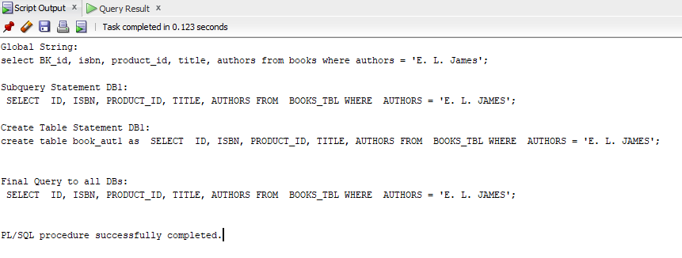

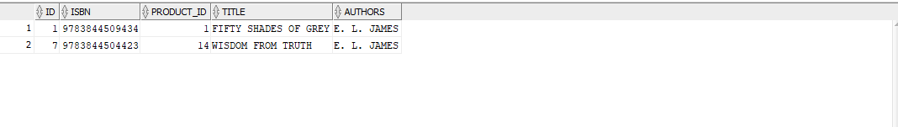

**-- 2. Search for all CDs that feature a specific artist**

begin

AUTO_CODE_GENR ('select music_id, msc_title, artists, record_company, msc_description from music_cd where artists = ''MARK RUFFALO''', 'msc_artist');

end;

-- Table creation script output

create table msc_artist1 as SELECT ID, TITLE, ARTISTS, RECORD_COMPANY, DESCRIPTION FROM MUSIC_CD_TBL WHERE ARTISTS = 'MARK RUFFALO';

-- select from table

select * from msc_artist1;

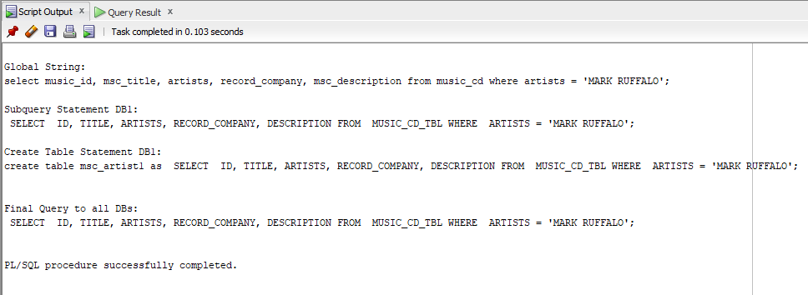

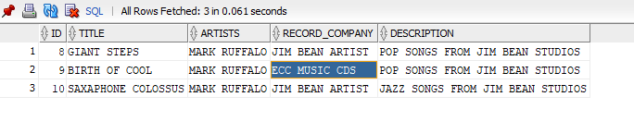

**--3. Display a few columns from each order in the local databases**

begin

AUTO_CODE_GENR ('select PURCHASE_ID, CUST_ID, SALE_DATE, SHIPPING, SALES_TAX, STATUS FROM ORDER', 'order_DB');

end;

SELECT ORDER_ID, CUSTOMER_ID, ORDER_DATE, SHIPPING, SALES_TAX, ORDER_STATUS FROM ORDERS;

create table order_dsp2 as SELECT ORDER_ID, CUSTOMER_ID, ORDER_DATE, SHIPPING, SALES_TAX, ORDER_STATUS FROM ORDERS

SELECT ORDER_ID, CUST_ID, ORDER_DATE, SHIPPING, SALES_TAX, ORDER_STATUS FROM ORD_TBL;

create table order_dsp3 as SELECT ORDER_ID, CUST_ID, ORDER_DATE, SHIPPING, SALES_TAX, ORDER_STATUS FROM ORD_TBL;

SELECT * FROM ORDER_DSP2;

SELECT * FROM ORDER_DSP3;

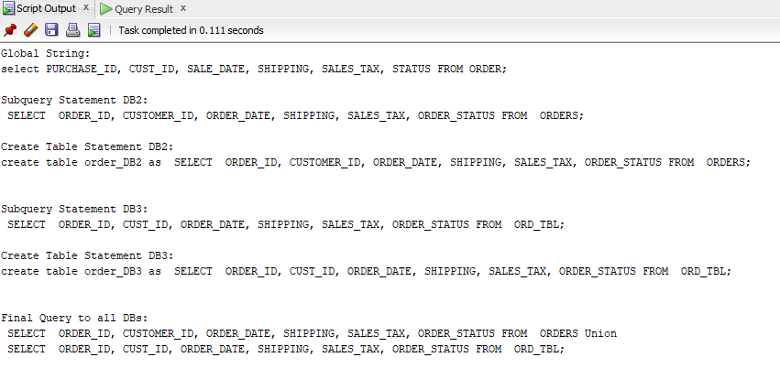

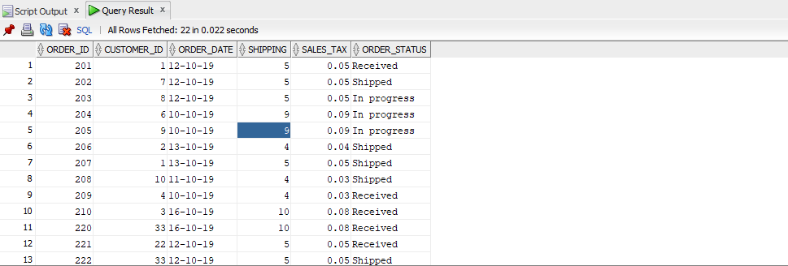

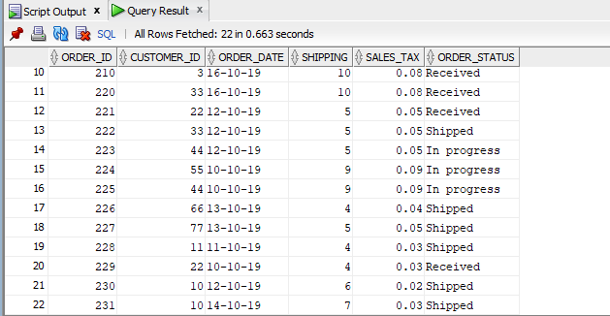

**-- 4. Search for each product with at least quantity N (you choose what N is)**

begin

AUTO_CODE_GENR ('SELECT PRODUCT_ID, PRODUCT_TYPE, TITLE, STOCK_COUNT FROM PRODUCT WHERE STOCK_COUNT >= 4', 'PRD_CNT_DB');

END;

SELECT PRODUCT_ID, PRODUCT_TYPE, TITLE, STOCK_COUNT FROM PRODUCT_TAB WHERE STOCK_COUNT >= 4;

SELECT PRODUCT_ID, PRODUCT_TYPE, PRODUCT_NAME, PRODUCT_QUANTITY FROM PRODUCT WHERE PRODUCT_QUANTITY >= 4;

SELECT PRD_ID, PRD_TYPE, PRD_NAME, PRD_QUANTITY FROM PRD WHERE PRD_QUANTITY >= 4;

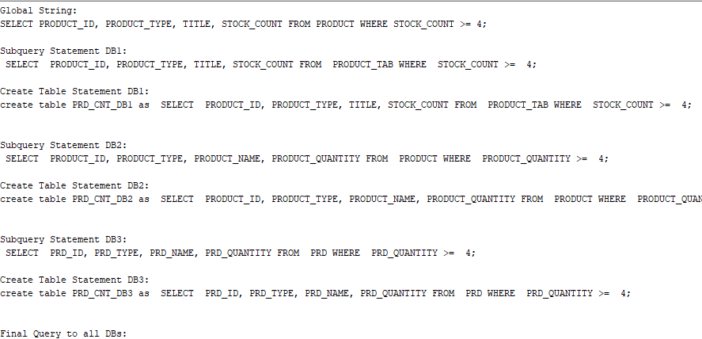

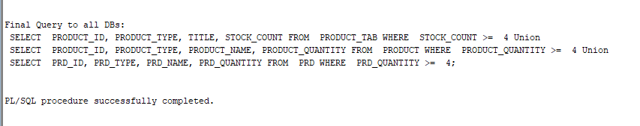

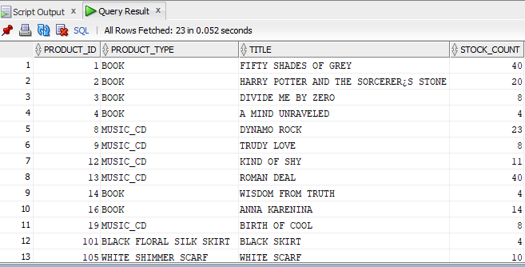

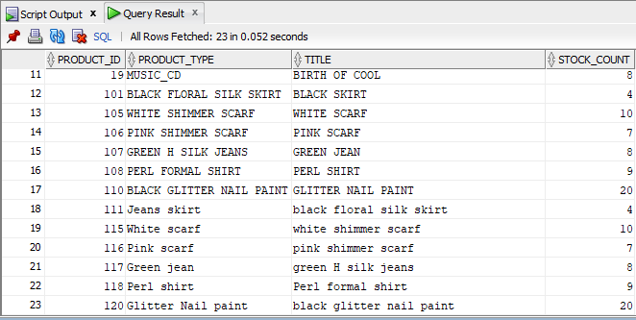

**-- 5. Display all orders of a particular customer**

begin

AUTO_CODE_GENR ('select purchase_id, cust_id, sale_date, shipping, sales_tax, status from order where CUST_ID = 10', 'order');

end;

SELECT ORDER_ID, CUSTOMER_ID, ORDER_DATE, SHIPPING, SALES_TAX, ORDER_STATUS FROM ORDERS WHERE CUSTOMER_ID = 10;

SELECT ORDER_ID, CUST_ID, ORDER_DATE, SHIPPING, SALES_TAX, ORDER_STATUS FROM ORD_TBL WHERE CUST_ID = 10;

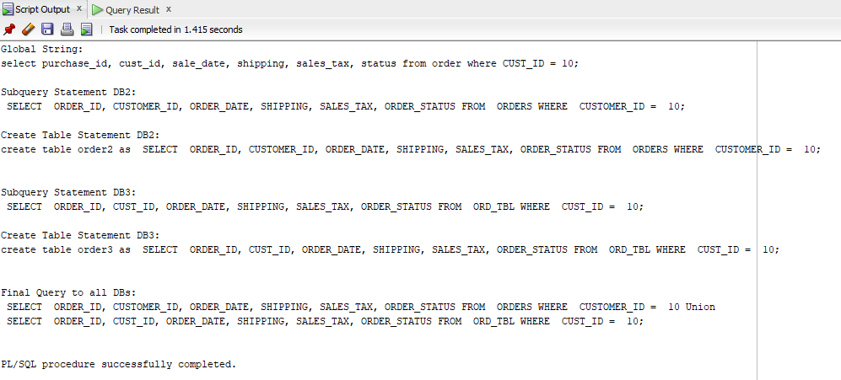

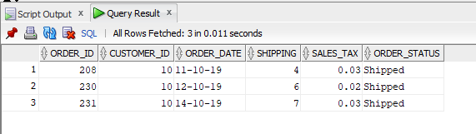

**--6. Different Scenarios**

**----Scenario 6.1: Display all information about a particular book title.**

begin

AUTO_CODE_GENR ('select BK_id, isbn, product_id, title, authors from books where title = ''A MIND UNRAVELED''', 'book_tit');

end;

-- Table creation script output

create table book_tit as SELECT ID, ISBN, PRODUCT_ID, TITLE, AUTHORS FROM BOOKS_TBL WHERE title = 'A MIND UNRAVELED';

-- select from table

select * from book_tit;

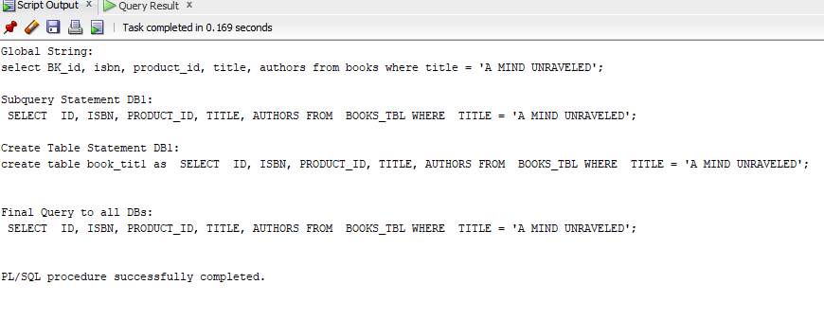

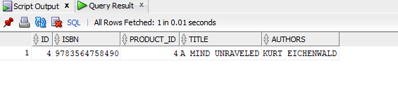

**--Scenario 6.2: Search for all CD’s for a particular record company.**

begin

AUTO_CODE_GENR ('select music_id, msc_title, artists, record_company, msc_description from music_cd where record_company = ''JIM BEAN ARTIST''', 'msc_company');

end;

-- Table creation script output

create table msc_company as SELECT ID, TITLE, ARTISTS, RECORD_COMPANY, DESCRIPTION FROM MUSIC_CD_TBL WHERE record_company = 'JIM BEAN ARTIST';

-- select from table

select * from msc_company;

